Preparation of Abstracts in One-Page Format for the IESS1.6 Book of Abstracts
Silviu Raileanu¹, Florin Anton¹ and Octavian Stocklosa² (author)
¹University Politehnica of Bucharest, Dept. of Automation and Industrial Informatics, Romania (affiliation)
{silviu.raileanu, florin.anton}@cimr.pub.ro (email)
²East Electric s.r.l., Bucharest, Romania
octavian.stocklosa@eastelectric.ro
Free line; please delete all colored text (basic_text)
The abstract should summarize the contents of the paper and should contain at least 170 and at most 400 words (do not exceed 1 page). The page style is in accordance with Springer-Verlag LNCS format. (basic_text)
The printing area is 122mm x 193mm. The text should be justified to occupy the full line width, so that the right margin is not ragged, with words hyphenated as appropriate. Please fill the page so that the length of the text is no less than 180mm.
Title. It should be 14 point, bold, centered and capitalized (i.e., nouns, verbs, and all other words except articles, prepositions, and conjunctions should be set with an initial capital).
Affiliations. Use 10-point type for the name(s) of the author(s) and 9-point type for the address(es). The affiliated institutions are to be listed directly below the names of the authors. Multiple affiliations should be marked with superscript Arabic numbers, and they should each start on a new line as shown in this document.
Text. For the abstract text, please use 10-point type and single-line spacing. We recommend using Computer Modern Roman (CM) fonts, Times New Roman, or one of the similar type-faces.
Figures and Tables. Authors can add one or two figures or tables to better present the thematic. Figures are to be numbered and to have a caption which should always be positioned under the figures, in contrast to the caption belonging to a table, which should always appear above the table. Captions are set in 9-point type and they are centered between the margins. (Fig. 1 shows an example). The distance between text and figure should be about 8mm, the distance between figure and caption about 5mm.
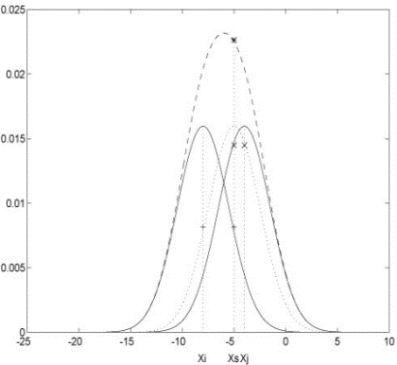 (figure)
Fig. 1. This is a sample figure caption. The last sentence of a figure caption should generally end without a period (figure_legend)

